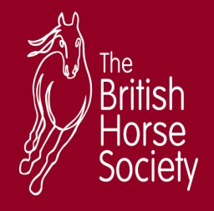
LITTLEBOURNE EQUESTRIAN CENTRE
LESSON PRICE LIST
FROM THE 1st October 2018

Riding school Office TEL: 01895 824 350
Email: info@littlebournefarm.com
Website : www.littlebournefarm.com

ALL RIDERS MUST COMPLETE A RIDER’S FORM BEFORE BEING ALLOWED
TO RIDE ANY HORSE

Off - Peak Peak
Weekdays Before 4pm Weekends.
After 4.30pm Weekdays
 | ½ Hour Assessment Lesson | £30 | £35
Private Lessons | ½ Hour Private Lesson | £30 | £35
 | 1 Hour Flat Lesson | £48 | £55
 | 1 Hour Jump Lesson | £52 | £59
Semi-Private Lessons | 1 Hour Lesson (2 riders) | £38 | £44
Group Lessons  (Max 8 Riders) | 1 Hour Group Lesson | £30 | £30
 | 1 Hour Pony Club Group Lesson | £28 | £28
Hacks | 1 Hour group Hack | £30 | £30
 | 2 Hour group Hack | £50 | £50
 | 5 Hour Pub/Picnic Ride | £87 | -
Other | Pony Days | £40-65 | -
 | Stunt Training Day | £100 | -
 | Course Hire per horse per | £15 (½ Hour) | £25 (1 Hour)
 | Pony Parties (per child inc food) | £35 | -
 | ½ Hour Private Lesson | £20 | £25
Livery Lessons  on  Own Horse | 1 Hour Private Lesson | £38 | £43
 | 1 Hour Group Lesson | £20 | £20

